_ _ _ _ _ _ _ _ _ _ -gas

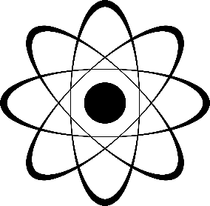

_ _ _ _ _ _ -prinzip



_ _ _ _ -plasma

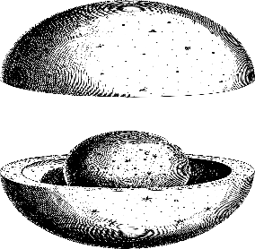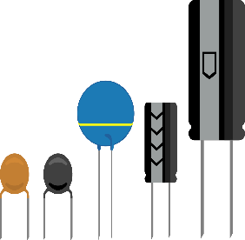

_ _ _ _ _ _ _ _ _ _ -element

_ _ _ _ _ _ _ _ _

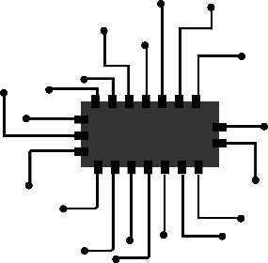

_ _ _ _ _ _ _ _ _ _

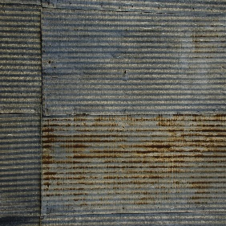

_ _ _ _ _ _ _ _ _

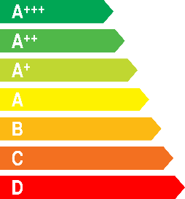

Notfall-_ _ _

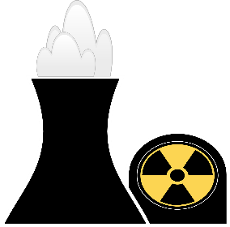

Pictures downloaded from:

https://pixabay.com/de/

https://www.piqsels.com/de

free commercial use